**Graduate Assistant Manual**

Desktop and Laptop Management

* Cloning
* Password Management

Digital Publishing Support

* Common Read Instructions
* Site Management

Sever Management

XML Encoding (crib sheets, guides, example witnesses)

* Kempe
* Ruskin

XML Review

XSLT

Website Management

**XML Encoding: Kempe**

Kempe Encoding Rules

Prepass Rules

1. Replace the following characters1 with their character references:

|  |  |  |
| --- | --- | --- |
| **Character Name** | **Character** | **Character Reference** |
|  |  |  |
| Ampersand | & | &#x0026; |
| Bracket | [ | &#x23A3; |
| Punctus | • | &#x00B7; |
| Thorn | þ | &#x00FE; |
| Yogh | ȝ | &#x021D; |
|  |  |  |

1 The ampersand (&) *must* be replaced first.

1. Insert HI before all red highlighted text (e.g. HI this is highlighted text).
2. Insert ADD before all red text (e.g. ADD this is red text).
3. Insert a three-letter color abbreviation before all other colored text (e.g. BLUthis is blue text, BRNthis is brown text, PURthis is purple text).

Preparing the First Pass

1. In Dropbox, browse to Digital Humanities Group\All\Projects\Kempe\XML\In Process.
2. Locate the text document containg the folio for which the first pass is to be performed—for example *Kempe Diplomat 0 (Fly)-15.txt* for f. 1r.
3. Open the document in Microsoft Word and locate the marker for the beginning of the folio—for example:

<lb/><ab n="0">f. 1r</ab>

for f. 1r.

1. Copy everything *between* this marker and the marker for the end of the folio:

<lb/><ab n="0"></ab>

Do not copy the markers.

1. Return to Dropbox and browse to Digital Humanities Group\All\Projects\Kempe\Schema & Templates.
2. Open the folio template, *folio.xml*, in Oxygen XML Editor.
3. Scroll down in the template to the comment

<!—Paste here.-->

1. Select the comment.
2. Paste the copied text from Microsoft Word.
3. Save as… *1r.xml* for f. 1r, *1v.xml* for f. 1v, *2r.xml* for f. 2v, and so on.
4. Begin the first pass. (Note that the @n for each <ab> must be updated: n=1" for Line 1, n="2" for Line 2, n="3" for Line 3, and so on.

Scribal Markup Rules

The primary calligrapher of *The Book of Margery Kempe* is a scribe named Salthows. Wherever a revision (i.e. addition or deletion) to this scribe's calligraphy is encountered in a hand other than his own, that revision must be attributed to one of manuscript's several annotators. This is achieved by pairing the @hand with the revision—for example:

<add hand="#*SCRIBES_NAME*">*addition*</add>

or

<del hand="#*SCRIBES_NAME*">*deletion*</del>

Special Case: @rendition

In certain cases—highlighting, for example—the TEI guidelines do not permit the use of the @hand. In these cases, the @rendition may be used.

On this project, the @rendition is used *only* with the <hi>; it is accompanied by an *abbreviation* of the scribal/annotator @hand—for example:

<hi rend="highlight" rendition="#SAL">

The abbreviation is used *only* with the @rendition.

The following table lists the scribe/annotators of *The Book of Margery Kempe* and their corresponding hand and rendition attributes:

|  |  |  |
| --- | --- | --- |
| **Scribe/Annotator** | **@hand** | **@rendition** |
|  |  |  |
| Salthows | #SALTHOWS | #SAL |
| Little Brown | #LITTLE_BROWN | #LB |
| Mount Grace | #MOUNT_GRACE | #MG |
| Flag | #FLAG | #FLA |
| Tiny Brown Notae | #TINY_BROWN_NOTAE | #TBN |
| Big Brown | #BIG_BROWN | #BBR |
| Plummet | #PLUMMET | #PLU |
| Big Black | #BIG_BLACK | #BBL |
| Ruby Paraph | #RUBY_PARAPH | #RP |
| Red Brackets | #RED_BRACKETS | #RB |
| Big Red N | #BIG_RED_N | #BRN |
| Faded Red Blotch | #FADED_RED_BLOTCH | #FRB |
| Red Ink Annotator | #RED_INK_ANNOTATOR | #RIA |
| Final Folio 1 | #FINAL_FOLIO_1 | #FF1 |
| Final Folio 2 | #FINAL_FOLIO_2 | #FF2 |
| Librarian | #LIBRARIAN | #LIB |
|  |  |  |

Substitution Rule

Wherever an <add> occurs by overwriting, it *must* follow/effect a <del>. If an <add rend="overwriting"> follows a <del rend="erasure"> (or other form of deletion for which a @rend has been provided), the <del> and <add> are to be interpreted as occurring separately and NOT as parts of a <subst>. If an <add rend="overwriting"> follows a <del> for which no @rend has been provided, the <add> is to be interpreted as effecting the deletion, and both the <del> and the <add> should be enclosed within a <subst>, for example:

<subst hand="*#SCRIBES_NAME*"><del>*deletion*</del><add rend="overwriting">*addition*</add></subst>

The @hand is necessary only when the hand effecting the substitution is different from the underlying hand (i.e. the hand substituted).

Left and Right Marginalia Rules

Left and right marginalia are encoded as additions to the beginnings or to ends of the anonymous blocks (<ab>s) that comprise the body of *The Book of Margery Kempe*—either before or after the content of those blocks—for example:

<ab><add>*marginalia*</add>*content*</ab>

or

<ab>*content*<add>*marginalia*</add></ab>

When encoding left and right marginalia:

1. At a minimum, encode the marginalia as follows:

<add place=margin-*left/right*" hand=#*SCRIBES_NAME*">*marginalia*</add>

1. If the marginalia spans more than one line, insert <lb>s as appropriate—for example:

<add place="margin-*left/right*" hand="#*SCRIBES_NAME*">*line 1*<lb/>*line 2*</add>

—but *only* if *all* lines can be attributed to the *same* scribe *and* as parts of a *single* intervention within the manuscript. If *all* lines cannot be attributed to the *same* scribe *and* as parts of a *single* intervention, follow Rule #1 above.

1. If the marginalia has been "decorated," append the <hi> and the rend and rendition attributes—for example:

<hi rend="box_" rendition="#*ABBREVIATION*"><add place="margin-*left/right*" hand="#*SCRIBES_*

*NAME*">*line 1*<lb/>*line 2*</add></hi>

—where box*#* corresponds to one of the shapes below.

**Box Shapes for "Decorated" Marginalia**

|  |  |  |
| --- | --- | --- |
| box1 | = |  |
|  |  |  |
| box2 | = |  |
|  |  |  |
| box3 | = |  |
|  |  |  |
| box4 | = |  |
|  |  |  |
| box5 | = |  |
|  |  |  |
|  |  |  |
|  |  |  |
| box6 | = |  |
|  |  |  |
| box7 | = |  |
|  |  |  |
| box8 | = |  |
|  |  |  |
| box9 | = |  |
|  |  |  |
| box10 | = |  |
|  |  |  |
| box11 | = |  |
|  |  |  |
| box12 | = |  |
|  |  |  |
| box13 | = |  |
|  |  |  |
| box14 | = |  |
|  |  |  |
| box15 | = |  |

Top and Bottom Marginalia Rules

Top and bottom marginalia are appended to the <lb>s that precede and follow—and, thus, comprise the top and bottom margins of—the body of *The Book of Margery Kempe*. Since an <add> cannot be appended to a <lb> directly (<lb/><add>*marginalia*</add> will not validate), the marginalia must be enclosed within an <ab> before it can be appended—for example:

<lb/>

<lb/><ab><add>*marginalia*</add></ab>

<lb/>

<lb/>

Additionally, unlike left and right marginalia, for which only two @place values exist (i.e. *margin-left* and *margin-right*), top and bottom marginalia may be described as *top-left-corner*, *top-left*, *top*, *top-right*, *top-right-corner*, *bottom-left-corner*, *bottom-left*, *bottom*, *bottom-right*, and *bottom-right-corner* (note the absence of the *margin-* prefix). Each of these values is associated with a default position—and justification (i.e. left, center, or right)—on the folio, as illustrated below. (Note: bold lines correspond to the rules on each folio.)

|  |  |  |  |  |  |  |
| --- | --- | --- | --- | --- | --- | --- |
| top-left-corner | top-left | | top | top-right | | top-right-corner |
| margin-left | | Body | | | margin-right | |
| bottom-left-corner | bottom-left | | bottom | bottom-right | | bottom-right-corner |

When encoding top and bottom marginalia:

1. Encode the marginalia as follows:

<ab><add place="*position*" hand="#*SCRIBES_NAME*">*marginalia*</add></ab>

1. If the marginalia spans more than one line, encode the marginalia as follows:

<ab><add place="*position*" hand="#*SCRIBES_NAME*">*line 1*<lb/>*line 2*</add></ab>

1. if the marginalia is "decorated," encode the marginalia as follows:

<ab><hi rend="box_" rendition="#*ABBREVIATION*"><add place="*position*" hand="#*SCRIBES_*

*NAME*">*line 1*<lb/>*line 2*</add></hi></ab>

Kempe XML Example: *Folio.xml*

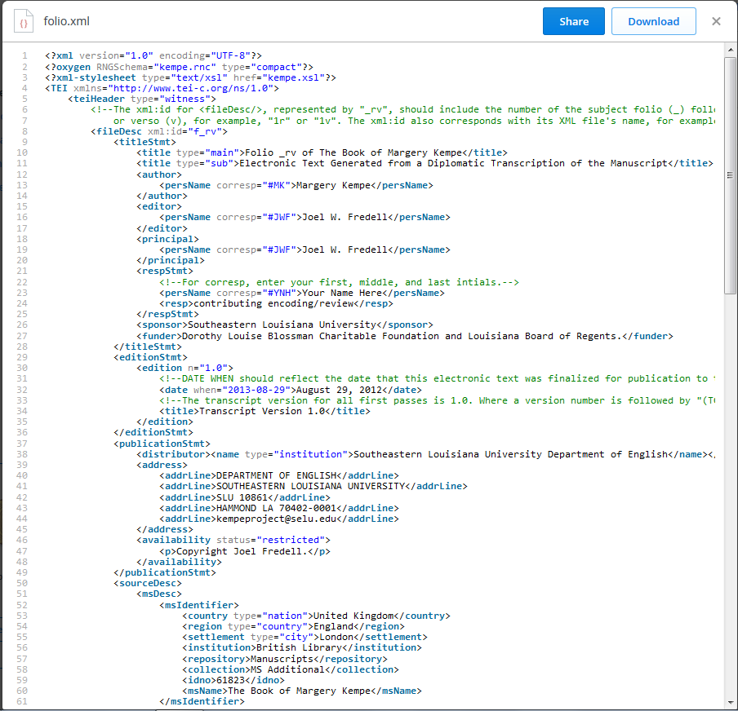

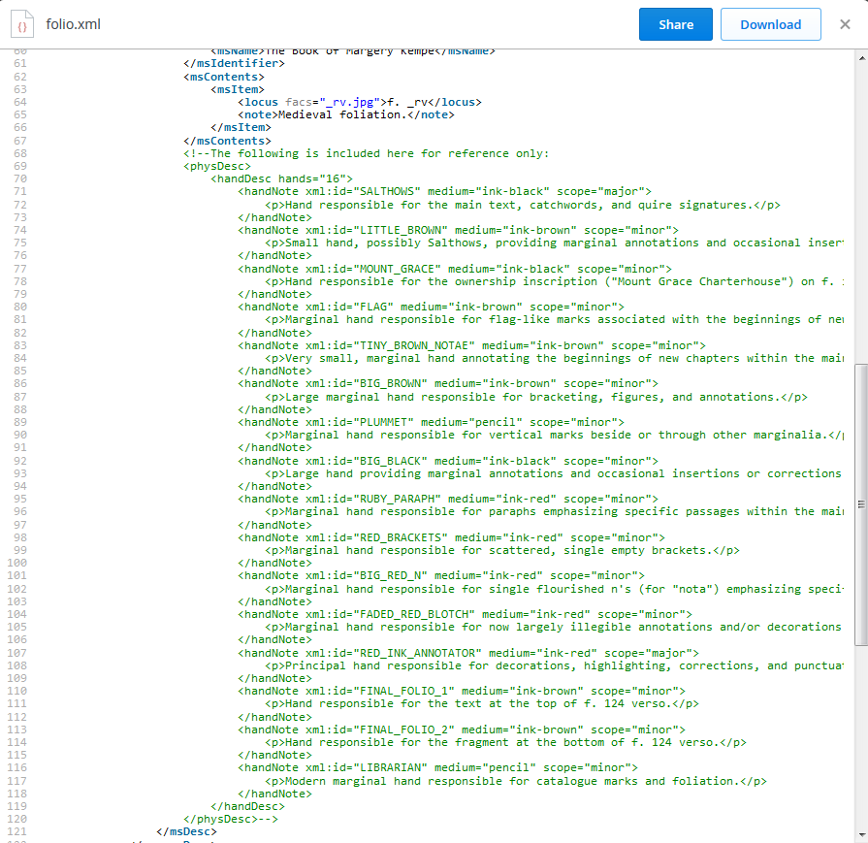

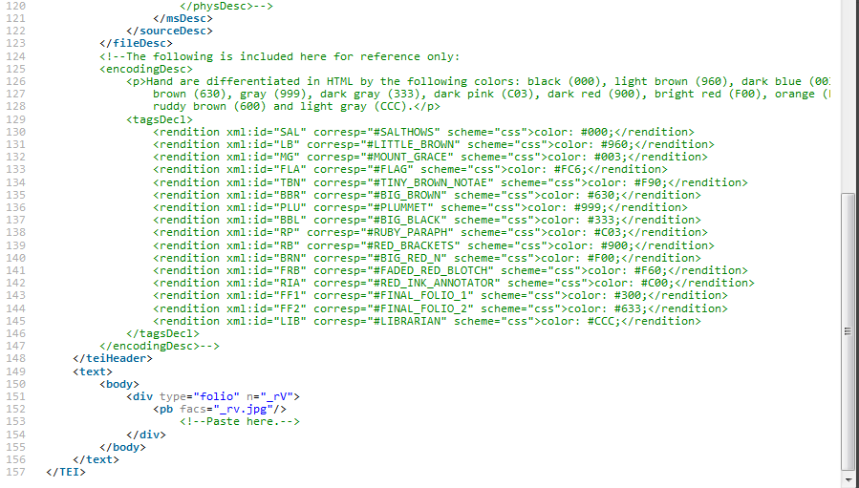

**Ruskin XML Example: Apparatus_ms.xml**

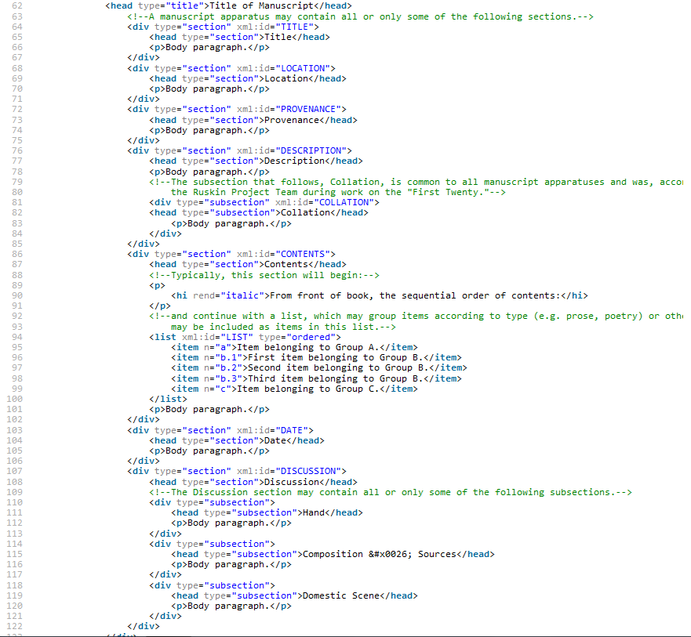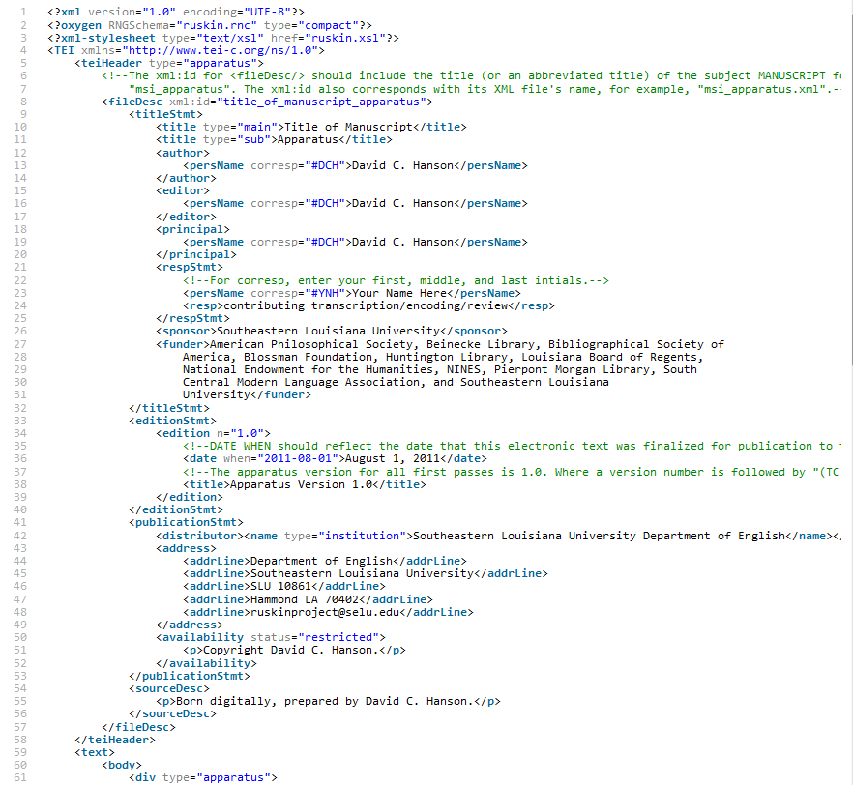



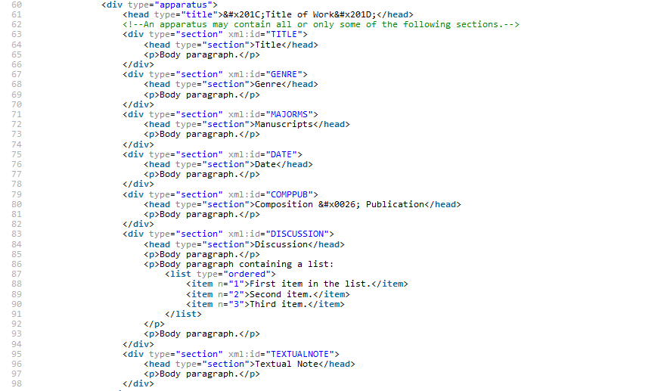

**Apparatus_work.xml**

**Witness_ms.xml**

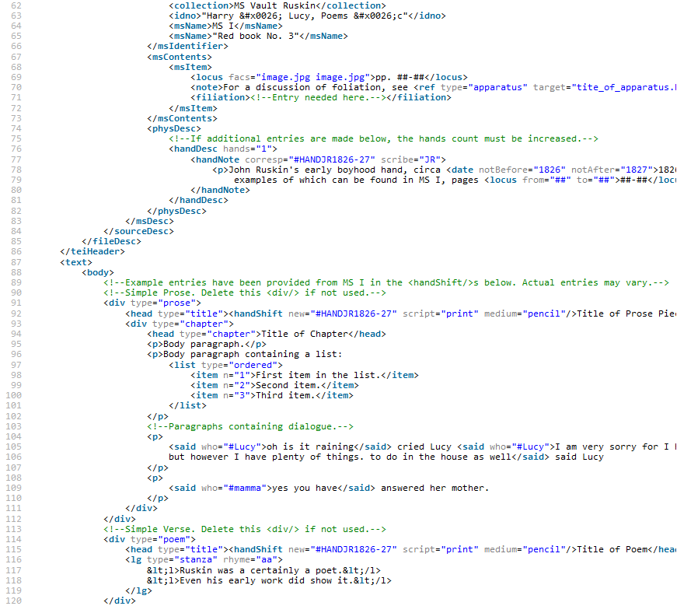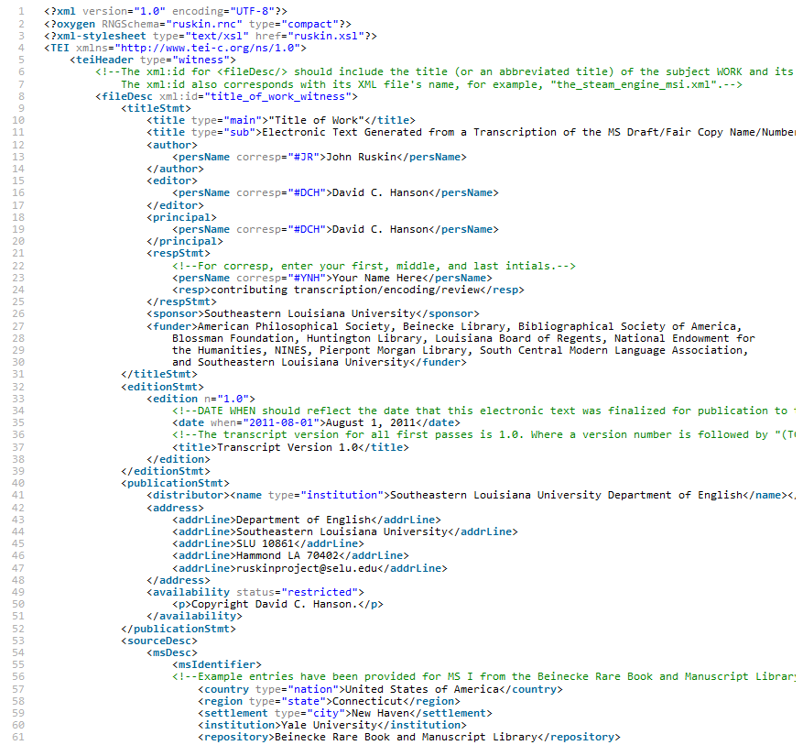

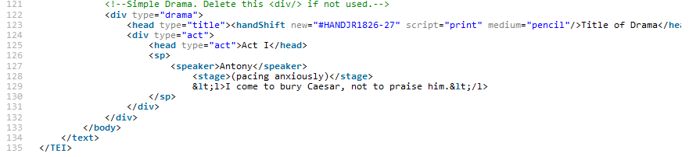

Witness_print.xml

